# Project Name: Retrieving the Product Details Using the Product ID.

# Output:

### Landing Page:

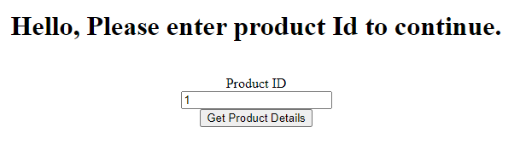

### Database return Page:

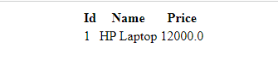

### If no product is available in the database:

